Town of Cortlandville, New York

Business District
Design Specifications

ADOPTED AS A TOWN POLICY

MAY 4, 2005

Document prepared by:
Town of Cortlandville Planning Board
&
Bailliere Consulting

Illustrations and Photos by:
Bailliere Consulting
TABLE OF CONTENTS

Cortlandville, New York
Business District
Design Specifications

Purpose, Scope, Authority & Definitions………… …………………………………… 3

1 Site Planning & Landscaping………………………………………………………… 4

2 Scale & Massing………………………………………………………………….…… 6

3 Building Height & Roof Design……………………………………….……………… 9

4 Proportions………………………………………………………………..…………… 10

5 Fenestration………………………………………………………….………………… 11

6 Materials & Colors………………………………………………..…………………… 12

7 Lighting & Miscellaneous Items……………………………….…………………… 14

PURPOSE, SCOPE, AUTHORITY & DEFINITIONS
PURPOSE

The purpose of the Business District Design Specifications is to enable the Town to achieve the following planning objectives:

- To promote new development and redevelopment that is compatible with its surroundings so that it does not detract from the Town’s rural character, scale and mass along the Route 281/13 corridor, and so that it protects property values, enhances the economic vitality of the area, and prevents the creation of visual blight;

- To reduce the visual impact of large areas of parking and to encourage development and redevelopment that is sensitive to residents and property owners by creating an identifiable character for Cortlandville that fosters a sense of community among neighbors, merchants, businesses and property owners;

- To create a safe and attractive physical environment designed at the scale of the pedestrian that increases pedestrian use along the route 281/13 corridor, while at the same time serving motorized and non-motorized uses; and

- To encourage high–quality design for all new development and redevelopment projects that protects and enhances open space, rural characteristics and the natural environment of the area acknowledging the fact that maintaining and enhancing natural characteristics along the corridor also provides additional benefits for aquifer protection, recreation and visual enjoyment.

SCOPE

These specifications provide design requirements for all new construction, additions and exterior alterations of properties within the Town of Cortlandville’s Business–1, Business–2 and Business–3 Districts.

Construction, additions or alterations to structures that would be in excess of 30,000 s.f. (defined hereafter as ‘large commercial structures’, have additional requirements as set forth in these specifications.

The boundaries of these business districts (referred to collectively as the ‘business district’) are determined by the current zoning map on file at the town offices.

AUTHORITY

This document is intended to be used as a Town Policy in conjunction with the Cortlandville Town Code. In the event of a conflict or discrepancy between these specifications and other sections of the ordinance, the most restrictive rule shall apply.

The Town of Cortlandville Planning Board may grant waivers to the requirements of this document under the following circumstances, provided the waiver would not impose significantly more negative impacts on nearby properties or the sole source aquifer:

1. Strict application of the specifications would result in an exceptional undue hardship to the owner of the property.

2. An alternative proposal would satisfy the intent of the requirements as well as, or better than, compliance with the original specifications.

3. The new location requirements for parking and building layouts are not possible in addition and remodeling projects.

The images and illustrations found in this specification are intended to be used as examples only, and should not be interpreted as literal instructions or architectural styles that the town desires.

DEFINITIONS

- This document is a policy, which offers suggestions and guidance in the actions that come about during the development process and consequently mandates are not in any way made or suggested. To that end the verb “should” and the transitive verb “provide” as used in this policy are to be interpreted as being synonymous with the transitive verb “desirable”.

- Where strict adherence to specific design feature is not required the terms “suggested”, “encouraged”, “where possible”, “may”, “as possible”, “recommended” or “attempt” are used.

Section 1 SITE PLANNING & LANDSCAPING
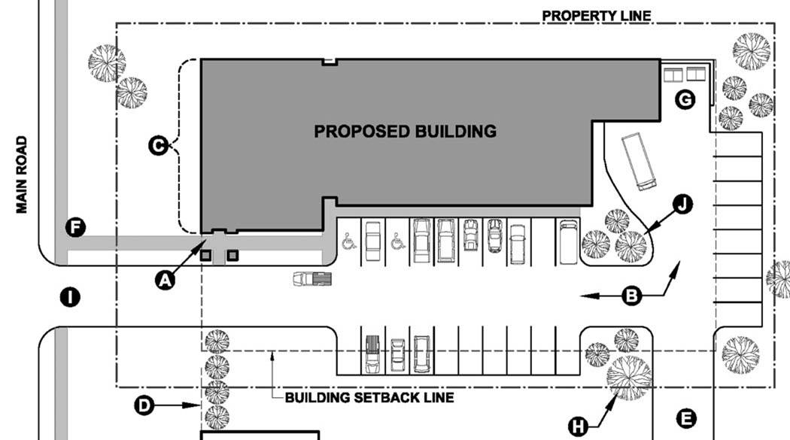
1.1 The primary building entry should attempt to be placed at the front of the building (facing the front lot line) and be clearly identifiable from the street. (A)

1.2 Parking should be placed at the side or rear of the lot and screened from view whenever possible. Break the parking areas up into groups of no more than 20 spaces per area (40 for buildings in excess of 30,000 s.f.) separated by landscaping areas. (B) See 1.11

1.3 Place as much of the building width as possible at the front of the lot to maximize front façade exposure to the public. (C) The front façade should be kept parallel to the street, if possible.

1.4 To reinforce the “street-edge”, align with neighboring buildings which are also close to the front setback line. Landscaping should also be used to reinforce this line and provide screening. (D)

1.5 Parking lots should link with adjacent parking lots or provide shared parking areas which can serve neighboring buildings simultaneously. (E) This provides a secondary means of access to the site and can ease congestion on the main road. A second means of access for all properties with large commercial structures is required to provide a second means of access for emergency purposes.

1.6 Provide sidewalks for the full width of the property on all road frontages with a direct link to the primary building entry. (F)
Figure 1: Sample Site Layout. The building is brought forward as close to the street as possible, with parking and other services tucked around the side and back. This helps to define the identity of the street and gives the business maximum public exposure.
1.7 Loading docks, service areas and trash facilities should be located at the rear of the building and not visible from the street. Fences, walls and landscaping must be used to shield them from view from surrounding properties as directed by the town. (G)

1.8 Incorporate any existing, older trees into new site plan development whenever possible to reduce waste and salvage good shade trees. (H)

1.9 Minimize the amount of curb-cuts by having a single driveway in and out of the property from the main road whenever possible. Secondary access points from side roads are encouraged on larger projects when warranted. Curb cuts should only be as wide as necessary to accommodate needed lanes. Curb radiuses should be kept to a minimum. (I)

1.10 The parking lot areas should be designed in regular, rectangular shapes which only create as much paved area as absolutely necessary.

1.11 Provide raised–curb landscaped islands 400 s.f. or larger in size, with a minimum dimension of 10 feet, at ends of parking rows so that they are no farther than 100 feet away from any parking space. Each landscaped island should include at least three (3) trees and four (4) shrubs. (J)
© 2004 Bailliere Consulting

SITE PLANNING & LANDSCAPING Section 1
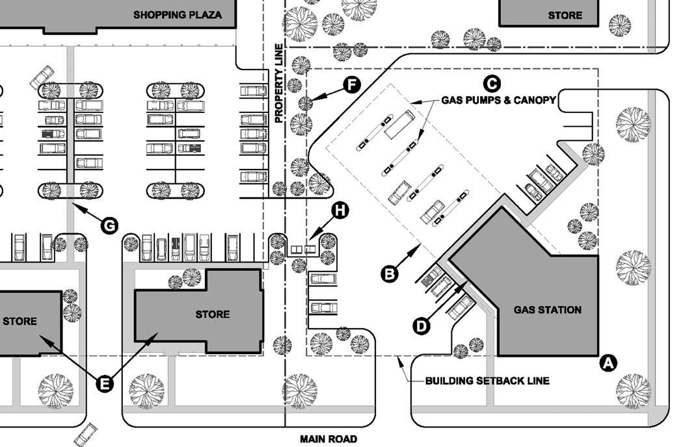
Figure 2: Redefining The Edges. Corner lots are especially important in defining the street. Special attention should be paid to bringing the building mass all the way out to meet the corner. Large shopping plazas should also attempt to infill the front of their lots with new commercial space to take advantage of the road frontage.
1.12 Corner lots should try to place as much building mass near the intersection, where desirable. (A)

1.13 Gas station canopies should be designed as an integral part of the station architecture whenever possible which allows for a visual and physical connection providing shelter between the pumps and the building. (B)

1.14 Alternative gas station layouts include placing the pumps near the rear of the lot while having the convenience store out in front near the street. (C) This helps to shield the utilitarian pump canopy and pulls the curb-cuts away from the intersection.

1.15 When it is not feasible to place the building entry directly on the front façade, attempts should be made to ensure that it is still readily visible and faces the main road or internal street. (D)

1.16 Large commercial structures set back far from the street should develop the land at the front of their lot with smaller businesses. (E)
1.17 Provide trees and other landscape screening to shield large parking areas from adjacent lots. (F)

1.18 Parking lots for large commercial structures (those in excess of 30,000 s.f.) should provide landscaped islands, continuous walkways and other non-vehicular areas which break up the expanse of blacktop and create protected pedestrian access as directed by the Town Planning Board. (G) Walkways should form a continuously protected network from the businesses out to the public sidewalks, include lawn buffers, benches, trees, shrubs, lighting and if applicable, bus stops. Crosswalks must be clearly designated, distinguished by pavers or concrete surface and should not exceed 30 feet in length. All walkway areas should be ADA compliant.

1.19 Loading docks, storage and trash facilities for large commercial properties should be screened from view with earthen berms, landscaped buffers or architectural screening elements as required by the Town Planning Board. (H) Truck delivery driveways for large commercial structures should be located so as not to disturb non-commercially zoned property.

© 2004 Bailliere Consulting

Section 2 SCALE & MASSING
Figure 3: Breaking Up The Masses Helps Reduce The Scale. Dividing the building volume up into a variety of shapes helps to reduce the perceived scale of the architecture and allows placement of the more important volumes up near the front of the site.
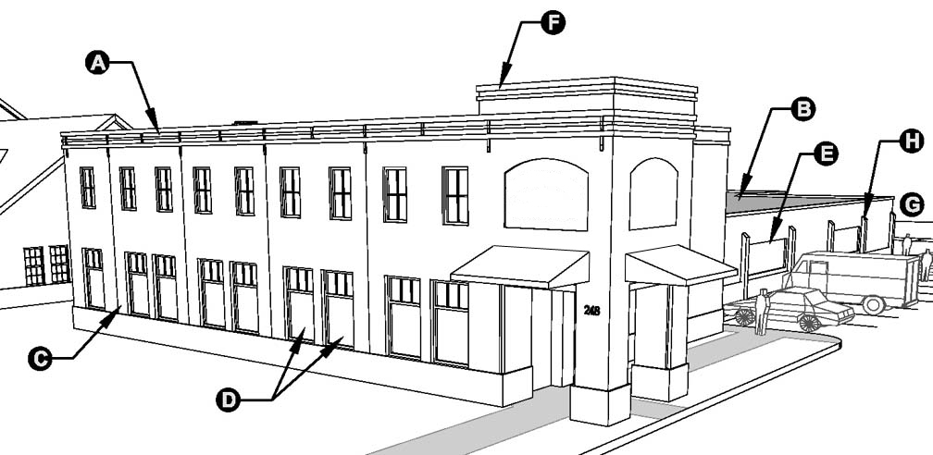
2.1 Where desirable, place a majority of the building mass close to the road to help define the street edge. In this example, the two-story mass is placed at the front of the lot, and likely contains the most public functions including reception, offices, showroom, retail space, etc. (A)

2.2 Less public areas such as warehouses, storage and manufacturing spaces should be shielded from view in the rear. This allows for warehouse/utilitarian style construction to be hidden behind the smaller scale public spaces that are in front. (B)

2.3 The building mass near the front of the site should be articulated with design features which give it a more pedestrian scale appearance. Natural, smaller scale materials should be used near the front of the site and pedestrian areas whenever possible (C)

2.4 Large scale features such as long, uninterrupted picture windows are not encouraged near the front of the site. They should instead be separated into smaller groups to help reduce their scale, and should have a vertical proportion. (D) The scale of these large windows can be further divided with the use of mullions and muntins.

2.5 Larger scale design features such as garage doors or long horizontal windows should be reserved for the rear of the facility whenever possible and out of sight from the street. (E)
2.6 Different massing at the entry to the building should be used to further define a reduced scale appearance and improve visibility of the entry from a distance. (F)

2.7 Larger scale materials such as concrete block or prefabricated panels should be reserved for the rear of the site and away from pedestrian areas. (G)

2.8 Areas of blank (unadorned) wall in excess of 50 feet in horizontal length along the front or sides of a building should be avoided. If they cannot be avoided, façade articulations or decorative designs should be added in regular rhythms to help animate the façade, or clusters of trees added to screen these areas. Continuous horizontal “banding” designs are not allowed as a method of animating blank wall areas, and instead repeating patterns or vertical elements, such as pilasters, are to be used. (H)

2.9 Building entry areas should employ the use of covered porches or similar recessed entry points which provide shelter from the elements and create deep shadows. See Also ‘Fenestration’. Porch areas should not be used for outdoor merchandise display. In lieu of a formal porch entry, smaller buildings may employ the use of a small canopy or awning over the main entry to provide a pedestrian scale appearance.
© 2004 Bailliere Consulting

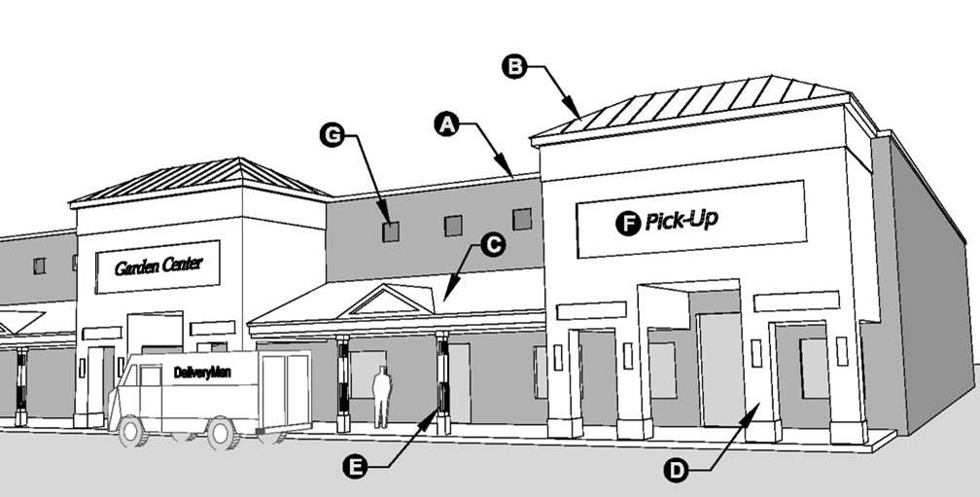
SCALE & MASSING Section 2
Figure 4: Alternate Design For Large Commercial (Big-Box) Structures. By articulating the façade with different massing elements, you can help to give a smaller scale appearance to an otherwise featureless mass.
2.10 Large commercial structures (those in excess of 30,000 s.f.) should incorporate fluctuations and different massing elements along the plane of the front façade to help reduce the overall scale and massing of the primary structure, which is shown shaded in grey in Figure 4. (A)

2.11 Massing elements (B) and other fluctuations in the plane of the front façade of large commercial structures should be used as follows:
- At both ends of the façade.
- To highlight entry points, exits, specialty areas (such as a garden/landscaping center or auto service) pick-up zones or separate places of business, if applicable.
- As additionally required so that no uninterrupted length of the façade shall exceed 100 feet measured horizontally.
- Have a depth of at least 8 feet and a width of at least 20 feet measured horizontally.
- Provide a fluctuation in the height of the roofline which is between 5% and 20% of the height of the primary structure.

2.12 In addition to façade fluctuations, large commercial structures shall include porches, arcades, awnings or similar features along 60% of the width of the front façade which provide pedestrian shelter and continuous walkways. (C) In the case of multiple tenant plazas, these arcade areas should act as the front facades and entry points to individual businesses.
2.13 The relative massing of the front façade should be slowly broken down into progressively smaller elements. For example, the larger tower elements (B) are supported on large piers (D) The towers frame smaller porches in between, which are supported on even smaller columns (E) These smaller columns are scaled to the pedestrian, and use the smallest scale materials.

2.14 The front façade or entry areas should be designed to accommodate façade lettering where appropriate. (F)

2.15 The primary structure (A) can be further enhanced with occasional variations in materials, such as the use of colored or textured masonry units in special areas to create localized patterns and help to animate blank areas of wall. (G) The use of banding designs (continuous horizontal stripes) across large areas of façade is not allowed.

2.16 Smaller scale materials such as brick and wood should be used on these front façade massing elements.

2.17 The size, scale, motif and use of materials for the front façade design should be kept consistent across the façade in order to tie the entire composition together. The use of a variety of design styles across the façade is not allowed.

© 2004 Bailliere Consulting

SCALE & MASSING Section 2
Figure 5: Photo/Rendering of Home Depot and Commercial Plaza; East Greenbush, N.Y. Warehouse style store construction is concealed behind smaller scale brick façade elements and arcade in front. The addition of a lawn area in front with trees helps to soften the appearance of the building and give it a more inviting appearance.
2.18 Large commercial structures should provide an area of lawn and tree clusters no less than 20 feet deep along 60% of the width of the front façade.

2.19 The sides or rear facades of large commercial structures (which might otherwise be blank) which are visible from adjacent properties and public or private roads should be designed as follows:
- No uninterrupted length of the façade shall exceed 100 feet measured horizontally without breaks or fluctuations in the plane of the façade.
- Breaks or fluctuations in the façade should have a depth of at least 2 feet, a width of at least 6 feet measured horizontally, and extend the full height of the façade. These fluctuations can be used for concealment of emergency exit doors.
- Earthen berms and landscaped buffers as required by the Town Planning Board. These may consist of clusters of evergreen trees which complement the rhythm of the adjacent architecture, or evergreen trees planted no less than 20 feet on center in two rows which are offset/staggered from each other.

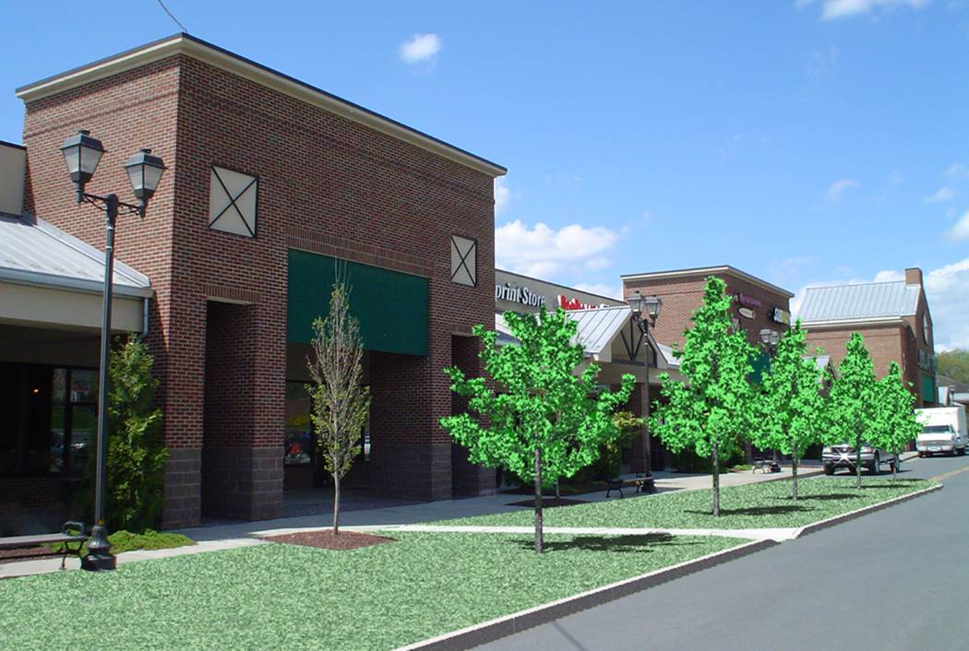
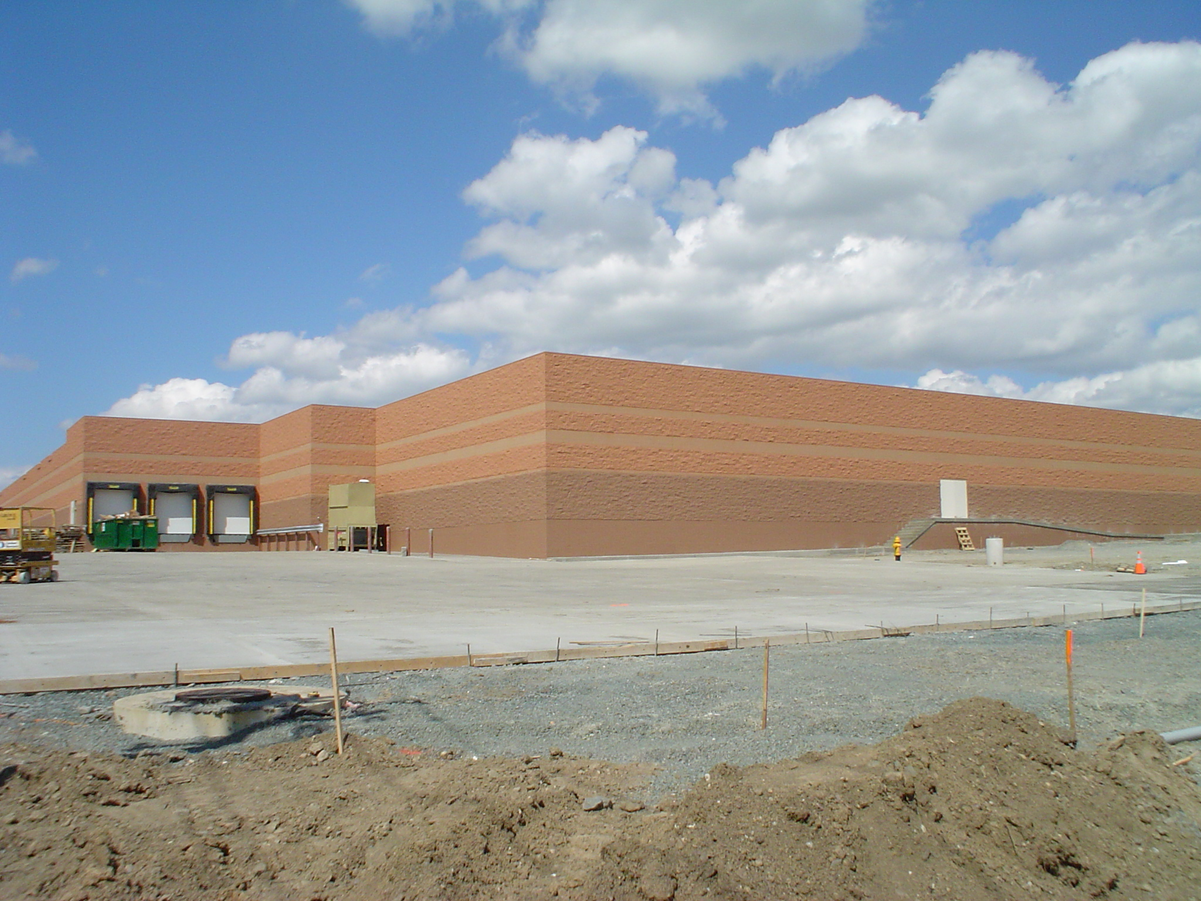
Figure 6: Target Store; East Greenbush, N.Y. This photo, taken from a main road, illustrates the large expanses of blank, unarticulated walls and lack of landscaping typically found in large commercial construction. This serves as an example of what the Town of Cortlandville is trying to avoid.
Section 3 BUILDING HEIGHT & ROOF DESIGN
3.1 The tallest façade of the building should face the street, stepping down in back if necessary.

3.2 The roof of the building should meet the sky gracefully and be in keeping with the scale of the structure itself. Overly large, bold or “inflated” roof and fascia designs are not allowed.

3.3 Flat roof structures should be capped by an articulated parapet design which acts as a structural expression of the building façade and its materials. (A) Fake roof fronts, built-out roof frames and similar applied designs are not allowed.

3.4 Subtle variations which help to differentiate the ‘base’, ‘middle’ and ‘top’ of the structure are required. (B)

3.5 Sloped roof structures are required to maintain a pitch between 6:12 minimum and 12:12 maximum slope on all primary roof areas. (Not including dormers, entry canopies or similar elements.) Mansard and shed roof designs are not allowed.

3.6 Buildings with sloped roofs are required to employ the use of dormers and gables along the front to help maintain a prominent façade when feasible. (C) These also help to divert rainwater and snow away from doorways.

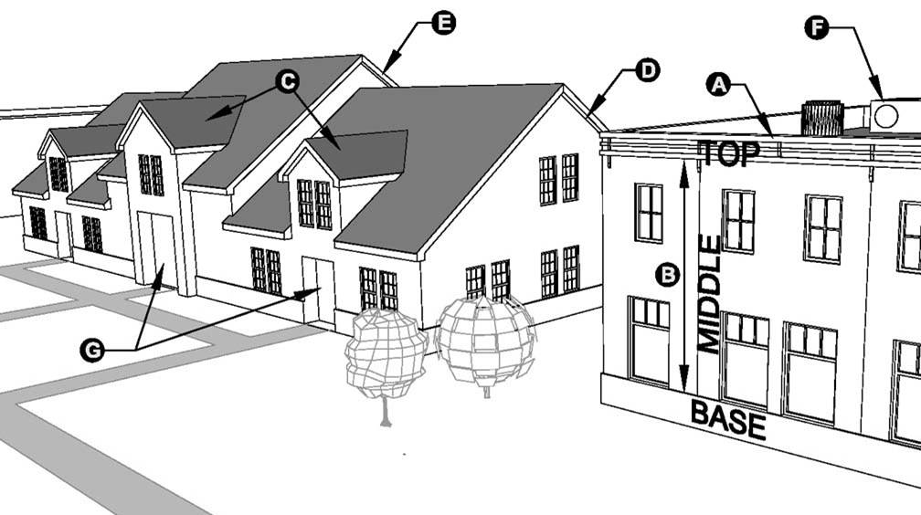
3.7 Buildings with sloped roofs should provide roof overhangs between 6” and 18” deep. (D)

3.8 Subtle breaks and fluctuations in the roofline should be used to highlight important areas of the building (such as the entry) and break up longer runs of façade/roof area. (E)

3.9 Air handling units, condensers, satellite dishes and other equipment placed on the roof should not be visible from the street or pedestrian areas, and instead should be placed near the back or behind building elements so they are shielded from sight or painted an unobtrusive color. (F)

3.10 The roof of a structure should be designed so as to divert the fall of rain and snow away from pedestrian areas such as walkways and doors. The use of canopies, awnings or similar protective designs are also encouraged at entry locations. (G)

3.11 Building rooftops which will be visible from elevated areas should be designed to shield mechanical equipment from view and reduce glare from reflective or bright surfaces.

Figure 7: Different Roof Configurations. A well designed building roof provides screening, reduces the building scale, diverts the fall of rainwater, highlights important areas and creates a graceful “cap” to the structure, among other things.
© 2004 Bailliere Consulting

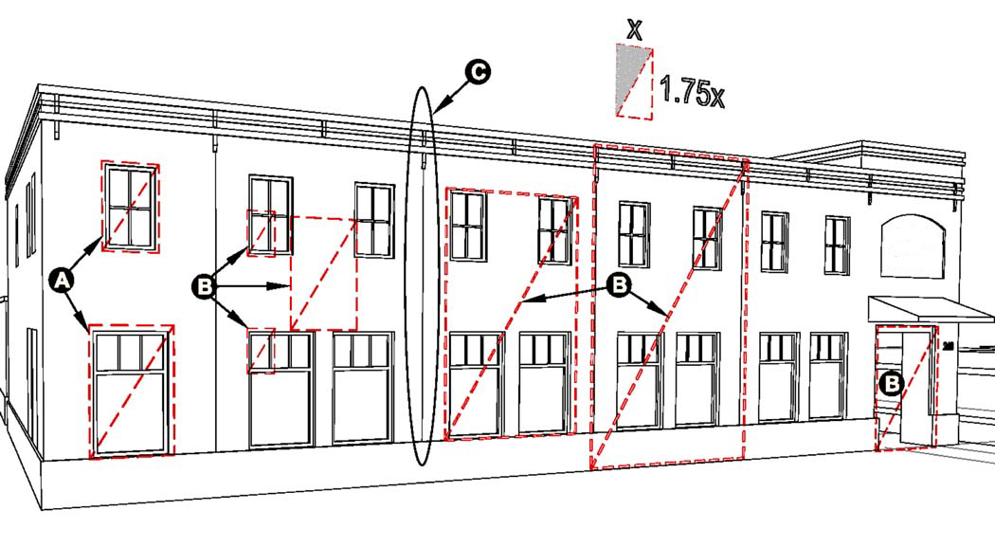
PROPORTIONS Section 4
4.1 The proportions of design elements such as windows, columns or bay spacing should be kept as consistent as possible on the façade. In this example, the windows on the second floor have the same width to height ratio as the windows on the first floor. (A)

4.2 Proportioning systems also can be very effective in guiding other design characteristics of the façade. Here, the same width to height ratio of the windows was used to determine the proportions of many other features. (B)

4.3 The use of vertically proportioned elements (elements which are generally taller then they are wide) is required to help give the building a taller, lighter and more stately appearance. Strong horizontal influences such as large fascias or banding designs are not allowed, or should be adequately balanced with vertical elements. (C)

4.4 The proportion of structural elements such as posts or columns should be appropriate to the weight they appear to be carrying. Columns which support larger masses, such as upper floors, generally have a low width to height ratio (For example 1:5). (D) Columns supporting lighter elements such as a porch roof generally have larger ratio (For example 1:15). (E) These relative proportions help balance a façade visually.
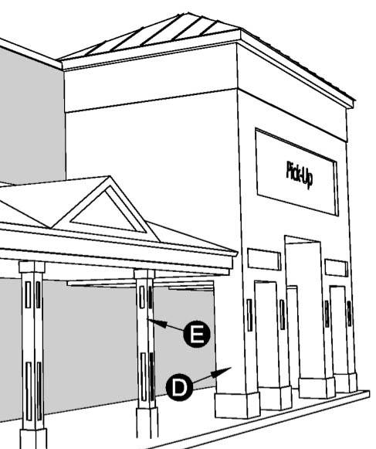
Figure 8: A Consistent Proportioning System. Many of the façade characteristics of this building are determined by the same width to height proportioning ratio (1:1.75). This can help to visually balance and tie the building together.
Figure 9: Relative Column Proportions. The thickness of the column or pier should reflect the amount of weight it appears to be carrying.
© 2004 Bailliere Consulting

© 2004 Bailliere Consulting

Section 5 FENESTRATION
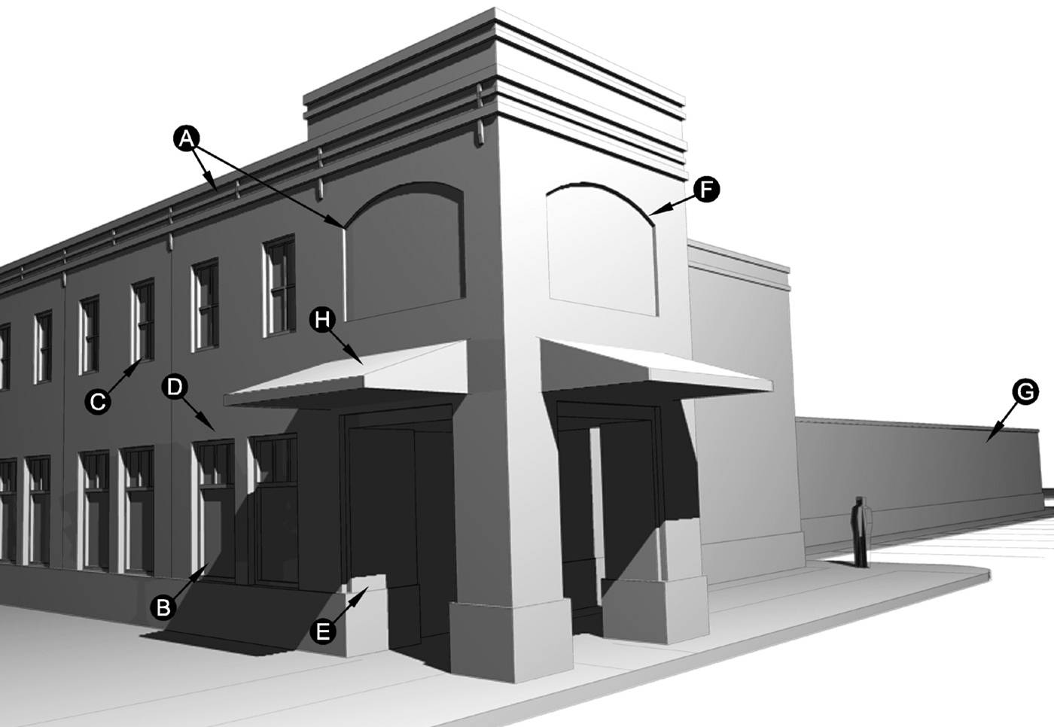
Figure 10: Fenestration Is A Measure Of The 3-Dimensional Depth Of A Façade Created By Fluctuations Or Openings In A Wall. Recesses such as archways or deep windows are two examples of fenestration. They help to give a façade a more 3-dimensional appearance by casting shadows and creating a visual contrast.
5.1 Articulations in the plane of the façade should be used to create an interesting design, reinforce rhythms and cast shadows. (A) Very flat façade designs are not allowed.

5.2 Typically, the most fenestration is found at the first floor level near pedestrian areas. Here, the use of larger openings and increased depth is required. (B) This creates a more open and inviting area.

5.3 In a building of two or more stories, the upper floors typically would have decreasing levels of fenestration. Here, smaller openings and less depth is usually found compared to the first floor. (C)

5.4 Openings in masonry buildings should express a structural lintel or arch to express how it is carrying the weight above. (D) Likewise, door and window frames can also use a wider trim at the head than is used on the sides to achieve the same visual effect.
5.5 The primary entry to a building is the best place to be creative with the use of depth in a façade. The added depth and articulation help to draw attention to the entry and highlight it as an important place. (E)

5.6 The use of façade articulation such as expressing the structural bays of the building with pilasters or other detailing should be used to animate an otherwise blank area of wall. (F)

5.7 In non pedestrian areas, such as the side or rear of the building, an increased level of fenestration is not as important, and may be scaled down if desired. (G)

5.8 The use of porches, colonnades, canopies or awnings is a great way to introduce shadows on a façade, and are suggested. (H)
© 2004 Bailliere Consulting

MATERIALS & COLORS Section 6
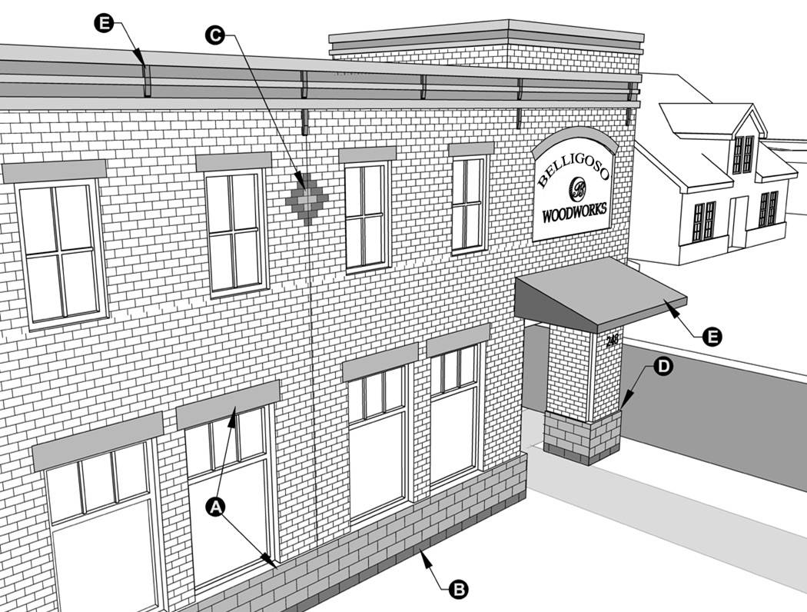
6.1 Smaller scale, natural materials are encouraged whenever possible, especially on the front façade and near pedestrian areas.

6.2 When using more then one material on a façade, it is required to have one as the dominant theme with the others acting only to compliment or accentuate the design. In this example, the main brick façade is accented with the use of a special concrete block at the base, with matching concrete lintels.(A)

6.3 Concrete block is not allowed as a primary façade material because of its larger scale, but can be used effectively to create design accents. (B)

6.4 Special patterns included in the façade or roofing material every now and then can help to create a more lively and interesting design, and are encouraged. (C)
6.5 When making a transition from one material to the next, it is required that the change occur at a hard edge or “bump-out” in the façade. This helps to create a surface for the first material to terminate into before the second one begins. (D)

6.6 When using multiple colors on the exterior of the building only one color should be used as the main theme, with the other colors used more sparingly to create accents. (E)

6.7 The main color theme should typically be of a natural, muted shade. Brighter, more vibrant colors such as red or yellow should generally be reserved for minor accents and highlights only, and should be used sparingly.

6.8 The use of contrast between primary and accent materials or colors can help enrich a façade design.
Figure 11: Smaller Scale Materials. The use of smaller building materials is recommended to help give the structure a more pedestrian scale.
© 2004 Bailliere Consulting

Section 6 MATERIALS & COLORS
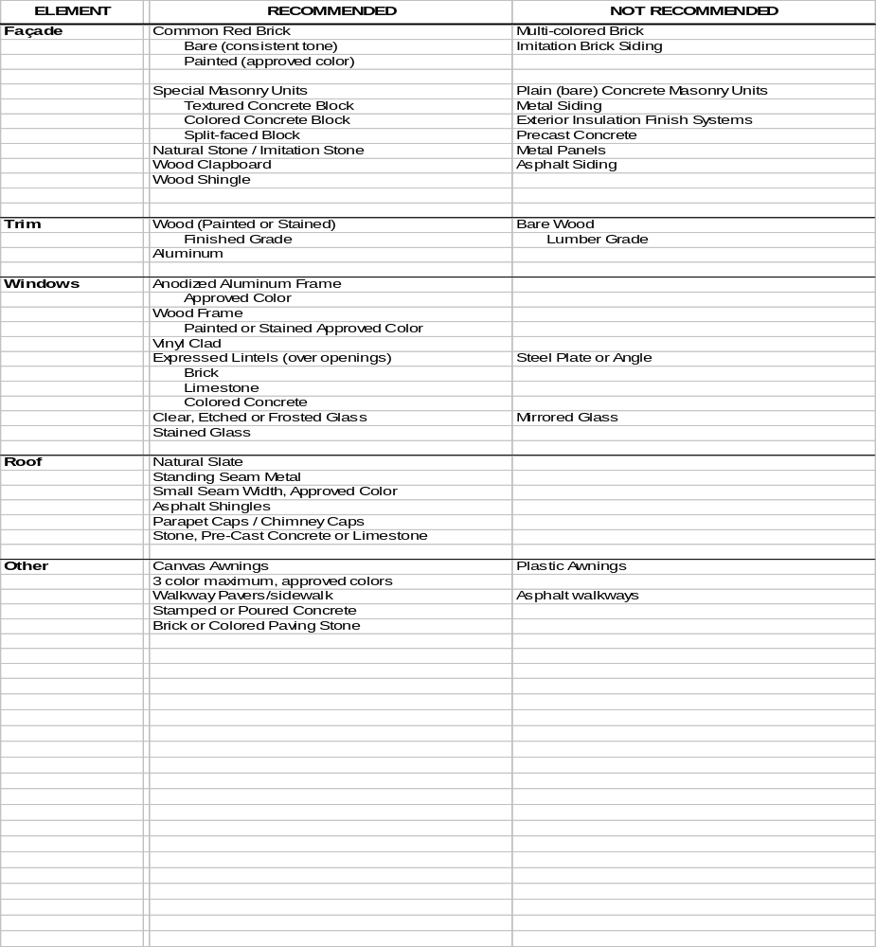
Table 1: Recommended Materials Chart. The following chart is intended as a general guide to the materials most and least preferred for use within the Business District. It is not intended to be comprehensive. Actual exterior materials and colors should be approved by the Town. Materials listed in the ‘Not Recommended’ column should only be used with prior approval of the Planning Board.
LIGHTING & MISCELLANEOUS ITEMS Section 7

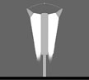
7.1 Site lighting should emphasize low level, targeted application which reduces nighttime light pollution. Parking and security lights should not be taller than the buildings which they serve, or nor taller than 25 feet above grade, whichever is less. Lighting for pedestrian walkways should be no taller than 12 feet above grade.

7.2 Exterior lighting photometric plans should be provided to the Planning Board for site plan review which indicate lighting levels and spread for each fixture. Plans should be provided on a fifty percent (50%) screened landscape plan with point to point photometric calculation at intervals of not more than ten (10) feet at ground level. A copy of all cut sheets for light fixtures and schedule shall be submitted and marked as to which information and data applies to the specific luminaire, including the lamp manufacturer.

7.3 In order to avoid unnecessary overlap and redundancy in lighting, care should be taken to provide lamps only where they are needed. Pre-existing lights on-site and on adjacent properties should be taken into account in the design process. When determining lighting needs for large areas of mixed parking and pedestrian access, the site lighting for the pedestrian routes should be designed first. The remainder of the lighting design for the larger scale parking lighting may then be used to fill in areas where it is still needed.

7.4 All exterior lighting used for signs, landscaping, walkways, parking lots, canopies and security should include full shielding or recessed fixtures which project light downward only, with the primary cone of light extending no more than sixty (60) degrees out from the vertical axis, with no exposed bulbs readily visible from the public way. The light from these fixtures should not spill over into adjacent properties, and provide only as much illumination as required on the target surfaces. See Figure 12.

7.5 Internally lit canopies and awnings require Planning Board approval.

7.6 Metal halide and incandescent lamps are recommended for typical exterior uses. Mercury vapor, low pressure sodium, high pressure sodium, neon and laser lights are not allowed.

7.7 When multiple types of lamps are used on the same site, attempts should be made to coordinate their style and select fixtures which create a common theme or character. Likewise, coordination with the fixture style of adjacent properties may be warranted.

7.8 Banners, streamers, balloons, blimps and similar devices are prohibited unless covered by a temporary permit.

7.9 Temporary signs such as those provided for announcing contracting projects, public elections and real estate listings are allowed provided they are no larger than six square feet in area and are removed immediately after completion of the event.

7.10 A single temporary sign advertising a special event is permitted no more than four times a calendar year for each business provided they are limited to a maximum of six square feet in area, are located on the business premises and are displayed for no more than seven consecutive days.

7.11 Each property may display a single American and/or State flag no larger than 6’x10’ provided it is flown from an approved flag pole not to exceed forty feet in height. Any additional flags located on-site, whether free-flowing or mounted on a surface, should be treated under the limitations for temporary signs.

7.12 As part of the land development agreement for the establishment of a large commercial structure (those in excess of 30,000 s.f.) provisions shall be made for the removal or adaptive reuse of the structure by the applicant should the facility not be used for a period of 12 consecutive months. Financial security may be required by the Town of Cortlandville.
Figure 12: Sign & Lamp Lighting Requirements. Exterior lamps should be shielded and designed to direct the light downwards at all times and only onto the surfaces which are intended for illumination.

